As a student studying agriculture and plant pathology, I have witnessed the growing role of advanced technologies like machine learning (ML) in tackling key challenges in plant disease management. This assignment delves into the latest innovations in ML and their transformative influence on plant pathology. The application of ML in agriculture, especially in plant disease control, has led to significant progress in diagnosing, predicting, and managing plant diseases. These innovations address global concerns such as crop losses, food security, and sustainable farming practices. Below is a detailed overview of some of the key contributions:

1. **Disease Detection and Diagnosis:**

ML-powered image recognition systems, trained on vast datasets, are capable of accurately identifying various plant diseases. These systems analyze symptoms like leaf discoloration, spots, and wilting. Smartphone apps such as Plantix and Agrio employ ML algorithms to help farmers detect diseases in real-time, facilitating quick responses and reducing reliance on traditional diagnostic methods, which tend to be more time-consuming.

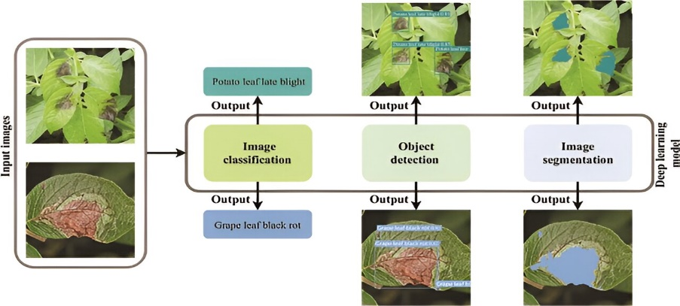

2. **Predictive Modeling and Early Warning Systems:**

Machine learning models utilize historical and real-time data, such as weather patterns, soil health, and crop growth, to predict potential disease outbreaks. For instance, ML can anticipate fungal diseases like late blight in potatoes by analyzing temperature and humidity trends. Such predictive models allow farmers to implement preventive actions, such as timely pesticide application, thus reducing the risk of yield losses.

3. **Genome Analysis for Resistance Breeding:**

The integration of ML in genomics has expedited the development of disease-resistant crop varieties. Algorithms process genetic data to identify specific genes linked to resistance against pathogens. This approach enables plant breeders to develop new crop varieties, such as rust-resistant wheat or wilt-resistant tomatoes, in a much shorter time frame than traditional breeding methods.

4**. Smart Disease Management Strategies:**

ML-based systems offer data-driven recommendations for disease management based on factors like disease severity, crop type, and environmental conditions. For example, precision agriculture technologies combine drones, sensors, and ML to monitor crop health and provide site-specific recommendations for pesticide application. This approach reduces pesticide overuse, cuts costs, and promotes sustainable farming practices.

5**. Pathogen Tracking and Evolution Monitoring:**

ML algorithms are utilized to analyze pathogen behavior, including mutation patterns and spread across various regions. This is especially important for managing diseases caused by rapidly evolving pathogens, such as rust fungi or bacterial blights. By understanding these patterns, researchers can develop better control strategies and anticipate the emergence of new disease strains.

6. **Integration with IoT and Big Data**:

The fusion of ML with Internet of Things (IoT) devices and big data analytics has enhanced its capabilities. Sensors placed in fields collect real-time data on factors like moisture, temperature, and nutrient levels, which are then analyzed using ML to assess disease risks. These integrated systems are being tested in crops such as rice, wheat, and cotton to enhance productivity and improve disease resistance.